Your First Program

Programming Fundamentals with C#

SPRING SEMESTER 2018

horizontal line

# Create a project

1. Open Visual Studio Community 2017
2. Select File > New > Project… from the menu bar.
3. Select "Visual C#" > "Windows Classic Desktop" > "Console App (.NET Framework)"
4. Ensure the box labeled "Create directory for solution" is checked.
5. Ensure the box labeled "Create new Git repository" is ***unchecked.***
6. Enter **"hello"** for the project name.
7. Enter **"C:\projects\cs_spring2018"** for the location.
8. Enter **"ch1"** for the solution name.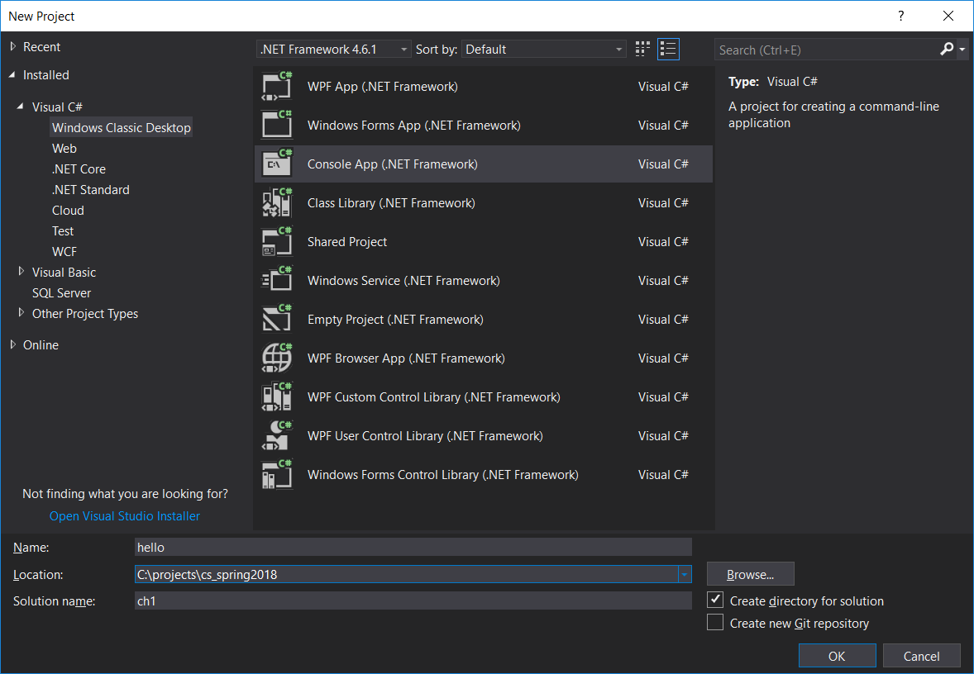
9. Select OK, and wait for it finish creating the project.

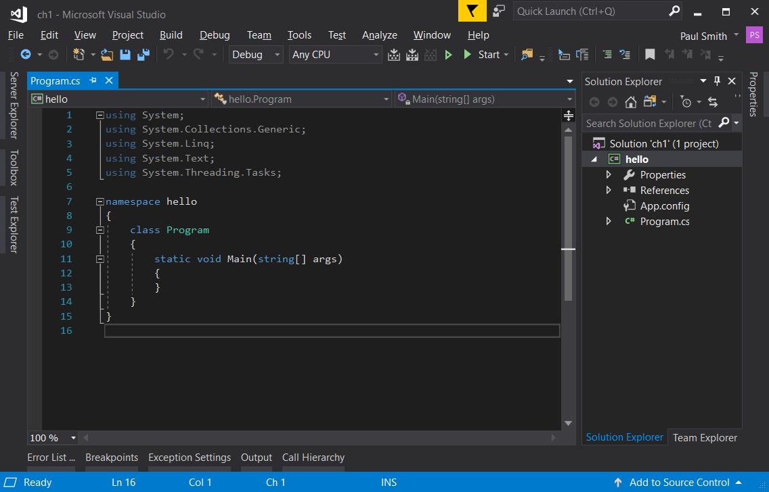

1. Now let's add some code the **Main()** method like so: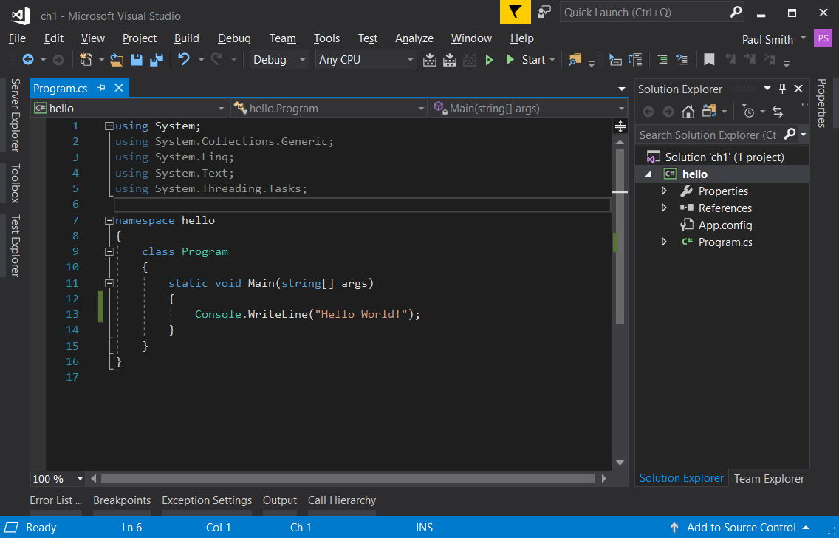
2. And now you can run the program by selecting "Debug" > "Run Without Debugging" from the menu bar.
3. Congratulations! You have now made your first C# program.

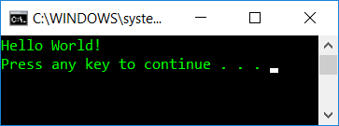

*NOTE: You can also start your program by pressing Ctrl+F5 on the keyboard.*